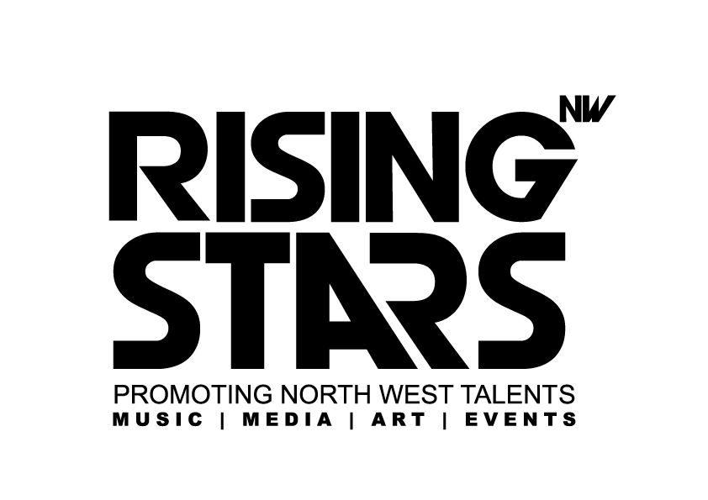
Rising Stars NW CIC
Registration Form

It would be great if you could fill in all of the sections of this form.
The information is used for evaluation and monitoring, and your details will be kept strictly confidential.

Full Name:....................................................................................................................... Age:...............

Date of Birth:.................................................................................................... Gender: Male/Female

Telephone No:............................................................... Mobile No:.....................................................

Email address………………………………………………………………………………………………………

Address:.................................................................................................. Postcode.................................

Parents/Guardian Contact Details:

Full Name:................................................................................... Relationship:........................................

Address:.................................................................................................. Postcode.................................

Phone No:................................................. Email Address:……………………………………………………

Do you have a medical condition we should know about? ☐ Yes ☐ No. If yes, please give details of

any conditions and any medication being taken: ......................................................................................

Are there any food allergies we should be aware of? ☐ Yes ☐ No
☐
If yes, please give details: .........................................................................................................................

Do you have any support needs we need to know about?, This may include with ADHD, Dyslexia, and Impairments. ☐ Yes ☐ No.
If yes, please give details of any support needs: ......................................................................................

Is the young person accessing any of the services? ☐ Yes ☐ No ☐
If yes, please give details of any services accessed: ..............................................................................

Do you have a support worker? ☐ Yes ☐ No If yes please add details below:

Name.................................................................................

Service........................................................ Contact............................................................

What are your current musical abilities? (Please tick as appropriate)

 | No Experience | Beginner | Intermediate | Expert
Guitar/ Bass
Drums/Percussion
Vocals /Singing
Keyboard Lessons

Other (please list below along with level of ability)

…………………………………………………………………………………………………………..…………

When you finish here at RSNW, what levels would you like to be for the following musical abilities? (please tick as appropriate)
 | No Experience | Beginner | Intermediate | Expert
Guitar/ Bass
Drums/Percussion
Vocals /Singing
Keyboard Lessons

Other (please list below along with level of ability)

……………………………………………………………………………………………………………..………

What, if any, kinds of groups, clubs, or organisations are you involved with during your free time?

………………………………………………………………………………………………………….………….
………………………………………………………………………………………………………….………….

How would you best describe your ethnic origin?

Asian or Asian British
☐ Indian
☐ Pakistani
☐ Bangladeshi
☐ Kashmiri
☐ Other Asian

Black or Black British
☐ Caribbean
☐ African
☐ British
☐ Somali
☐ Other black

Chinese or other
☐ Chinese
☐ Other ethnic group
☐ Unknown

Mixed
☐ White & Black Caribbean
☐ White & Black African
☐ White & Indian
☐ White & Pakistani
☐ White & Bangladeshi
☐ Other mixed

White
☐ British
☐ Irish
☐ Traveller of Irish Heritage
☐ Gypsy/Roma
☐ Polish
☐ Other White European
☐ Other White

☐ Prefer not to say
I agree to my contact details being used for all RISING STARS NW CIC mailings for any projects, events and training which may be relevant to me, on the understanding that this information will not be shared with any other company, project or government body apart from RISING STARS NW CIC. The information will be kept for as long as the project is running.

I agree to this information being used for the purposes of evaluation, to show how RISING STARS NW meets its aims and objectives. And to be contacted for follow-up interviews to see what impact the project has had on me as a participant. *

Your signature (or signature of parent/guardian if under 18) ___________________________________

Thank you for completing this form. The information that we collect from these forms will form a crucial part of the evaluation being conducted by RISING STARS NW. All information will be kept strictly confidential. Please contact RISING STARS NW for questions, or further information.

RSNW

Image Release Form
I hereby grant permission to the rights of my image, likeness and sound of my voice as recorded without payment or any other consideration to Rising Stars NW. I understand that my image may be edited, copied, exhibited, published or distributed and waive the right to inspect or approve the finished product wherein my likeness appears. Additionally, I waive any right to royalties or other compensation arising or related to the use of my image or recording. I also understand that this material may be used in different settings within an unrestricted geographic area.

Photographic, audio or video recordings may be used for the following purposes:

- Conference presentations
- Presentations for training courses
- Brochures and Informational presentations
- On-line distribution via RISING STARS NW CIC website & social media platforms
- Educational purpose

By signing this release I understand this permission signifies that photographic or video recordings of me may be electronically displayed via the Internet or in the public or in an educational setting.

There is no time limit on the validity of this release nor is there any geographic limitation on where these materials may be distributed.

This release applies to photographic, audio or video recordings. By signing this form I acknowledge that I have completely read and fully understand the above release and agree to be bound thereby. I hereby release any and all claims against any person or organisation utilising this material.

If this release is obtained from a participant under the age of 18, then the signature of the participant’s parent or legal guardian is also required.

Name _____________________________________ | Email _____________________________________
Phone ____________________________________ | Signature __________________________________
Date _ _ / _ _ / _ _ _ _

